 | SIMATS ENGINEERING  Department of Computer Science and Engineering
CSA15 Cloud Computing and Big Data Analytics
CO3 AT2 - Capstone Cloud Access and Service Integration Case Study Student Template
Course Code | CSA15 | Course Title | Cloud Computing and Big Data Analytics
Assessment | CO3 AT2 - Capstone Cloud Access and Service Integration Case Study | Submission Type | Individual digital case-study document
Faculty | Dr C. Rajesh Babu | Employee ID | SSETSCS415
Mode | Case study / capstone design reasoning | Submission | GitHub repository link through Google Classroom

How This Template Works
Read each case, connect it to the technical ideas learned in CO3 AT1, and then extend the design to your own capstone product. The answer must show cloud access, APIs, storage, serverless/event flow and edge/fog/cloud reasoning. Do not upload passwords, private keys, API tokens or sensitive personal data.

Student and Capstone Details
Student Name | Kavin.R
Register Number | 192511314
Class / Slot | Slot B
Capstone Title | CrowdCare Cloud Event Safety Platform With Density Estimation and Incident Routing
CO3 AT1 Evidence Link | To be added
GitHub Repository Link | To be added
Submission Date | 25-08-2026

Case 1: Cloud-Native Backend and Web API Architecture
Scenario
A food delivery company wants to deploy a cloud-native backend with web APIs, browser/mobile clients and shared cloud storage for receipts and delivery images. Design the architecture and explain the role of each component.

A. Case Architecture Diagram
Architecture for the reference case adapted to CrowdCare:
The CrowdCare platform follows the same cloud-native pattern required by the case: browser/mobile clients access a hosted frontend, the frontend calls authenticated REST APIs, serverless functions process requests and events, cloud storage holds event media, and a managed database stores structured event and incident data.
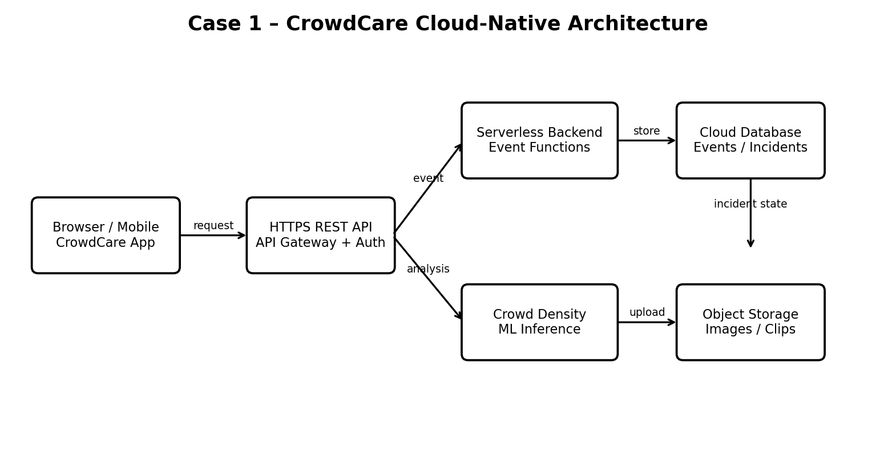

B. Component Role Explanation
• Browser/Mobile Client – Event staff and authorized users view crowd status, submit incident reports, and receive routed alerts.
• Hosted Frontend – Serves the CrowdCare web interface through a cloud-hosted application path.
• REST API Gateway + Authentication – Provides HTTPS API access and checks authenticated users before protected operations.
• Serverless Backend – Executes incident creation, routing, notification, density-result processing and event-driven business logic without managing servers.
• Crowd Density Estimation – Processes camera/sensor inputs or uploaded media to estimate crowd density and identify threshold breaches.
• Cloud Database – Stores events, zones, density readings, incidents, routing status, users and audit metadata.
• Object Storage – Stores incident images, short video clips and other unstructured event evidence.
• Monitoring/Logs – Records API, function and incident-processing activity for operational visibility and troubleshooting.

C. Capstone Extension: user-to-cloud workflow for your product
1. User opens the CrowdCare web/mobile client and authenticates.
2. The client sends an HTTPS request to the REST API.
3. The API authentication layer verifies the session/token and authorizes the requested operation.
4. Serverless functions read/write event, zone and incident data in the cloud database.
5. Camera/sensor density results or uploaded evidence are stored in object storage and processed through an event-driven function.
6. When density or incident rules are triggered, the routing function selects the responsible safety team/zone and sends a notification.
7. The resulting status is written back to the database and displayed on the dashboard.


Case 2: Storage and Serverless Upload Workflow
Scenario
A media startup must decide between SAN-backed storage, object storage and serverless processing for upload workflows. Recommend a deployment model and justify it.
Data / Event | Best Storage | Serverless Action | Reason
Event media / incident images | Object storage | Create metadata record and emit processing event | Scales for large unstructured files; durable and suitable for media.
Crowd-density result | Cloud database | Validate/store reading and update zone status | Structured, queryable data needed for dashboards and history.
New incident created | Cloud database + event bus | Invoke incident-routing function | Reliable event-driven workflow separates detection from routing.
Video/image upload completed | Object storage | Trigger serverless media/density processing | No always-on server is required; processing runs only when an upload arrives.

A. Storage and Serverless Recommendation
Recommendation: Use cloud object storage for images/video, a managed cloud database for structured metadata, and serverless functions for event-driven processing.
Why object storage: CrowdCare may receive many images or short clips from events. Object storage scales independently of compute and is better suited to unstructured media than SAN-backed storage for this use case.
Why serverless: Density processing, thumbnail generation, validation and incident routing are event-driven workloads. Serverless functions reduce idle infrastructure and scale during crowded events.
API access should use authenticated HTTPS. Media should be uploaded through controlled object-storage paths, with metadata and access permissions maintained in the application database.

B. Failure Handling and Cost/Performance Explanation
Failure handling: If an upload event fails, retain the original object and retry the processing event. Use idempotent functions so a duplicate event does not create duplicate incidents. Failed messages should move to a dead-letter queue for later review.
Database failures: Return a controlled error to the client, retry transient writes, and preserve the incident/media object so processing can resume after recovery.
Performance: Store large media outside the transactional database, process asynchronously, and keep dashboard queries focused on compact metadata and recent density summaries.
Cost: Serverless execution and object storage avoid paying for continuously running media-processing servers and allow capacity to scale with event activity.

C. Capstone Extension: one upload/event workflow
Example upload/event workflow: An event staff member uploads an incident image from the CrowdCare app. The file is stored in object storage. The storage service emits an upload event. A serverless function validates the file and extracts/associates event metadata. If the evidence is related to a crowd-density breach, the function invokes density analysis or records the density result. If an incident threshold is confirmed, another serverless function routes the incident to the responsible safety team and writes the routing status to the database.
Result: the user sees the incident state on the dashboard while the original media remains durably stored.
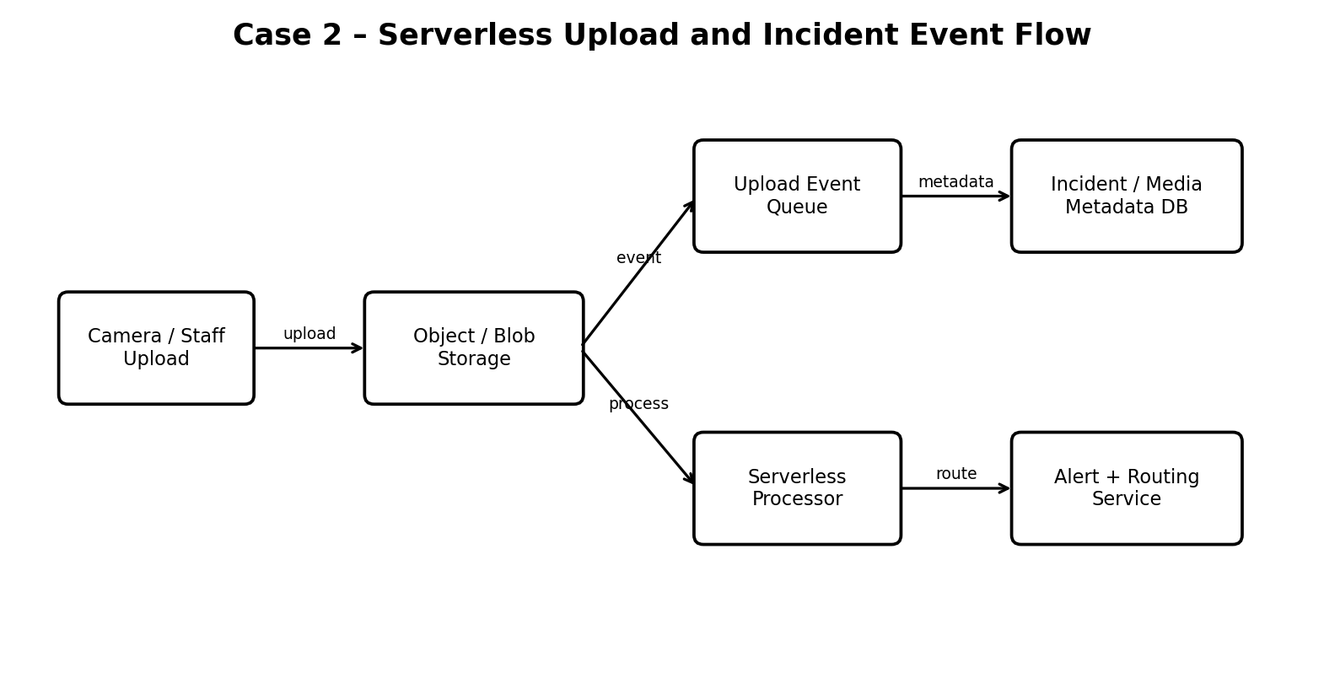

Case 3: Edge, Fog and Cloud Placement
Scenario
A smart-city platform needs low-latency decision-making near sensors while still using the cloud for analytics. Decide what runs at edge, fog and cloud.
Task | Layer | Latency Need | Data Volume | Reason
Camera/sensor capture | Edge | Very low | Continuous stream | Initial filtering and fast density estimation should happen close to the source to reduce latency and bandwidth.
Venue aggregation | Fog | Low | High | Combines readings from nearby cameras/zones and performs local threshold evaluation before sending selected data to cloud.
Emergency/local alert | Fog | Very low | Small | Immediate local decisions such as triggering a venue alert or escalating a zone incident should not wait for cloud round trips.
Historical analytics | Cloud | Seconds/minutes acceptable | Large | Stores long-term density history and supports model training, trend analysis and cross-event comparisons.

A. Edge/Fog/Cloud Architecture Explanation
Edge placement: Camera/sensor gateways perform lightweight preprocessing and first-level density estimation so urgent crowd conditions can be detected with minimal latency.
Fog placement: A venue-level fog node aggregates multiple edge streams, maintains zone-level state and performs local incident threshold checks. This reduces bandwidth and keeps safety actions available during temporary cloud connectivity problems.
Cloud placement: The cloud stores durable event history, incident records and media, runs broader analytics, maintains dashboards, supports model improvement and provides centralized monitoring.
Direct cloud access is still appropriate for dashboards, administration and non-urgent workflows. Safety-critical decisions should have an edge/fog path so a WAN delay does not prevent immediate local response.
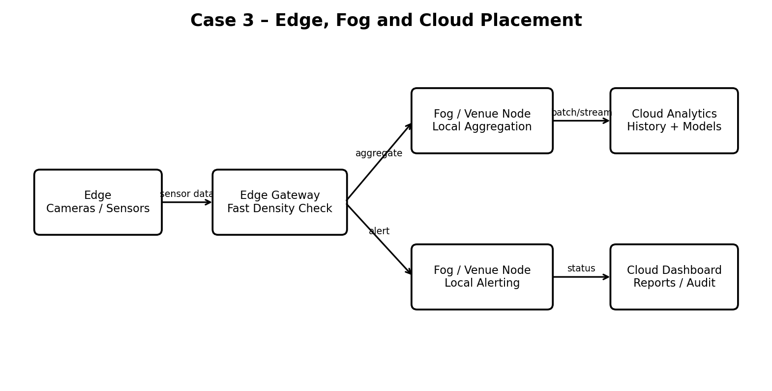

B. Capstone Extension or Direct Cloud Access Justification
Final CrowdCare Architecture
CrowdCare Cloud Event Safety Platform combines cloud access, authenticated APIs, serverless processing, object storage, structured cloud data, monitoring, and edge/fog processing. The architecture is designed to estimate crowd density quickly, create incidents, route them to the correct safety personnel, and retain auditable event information.
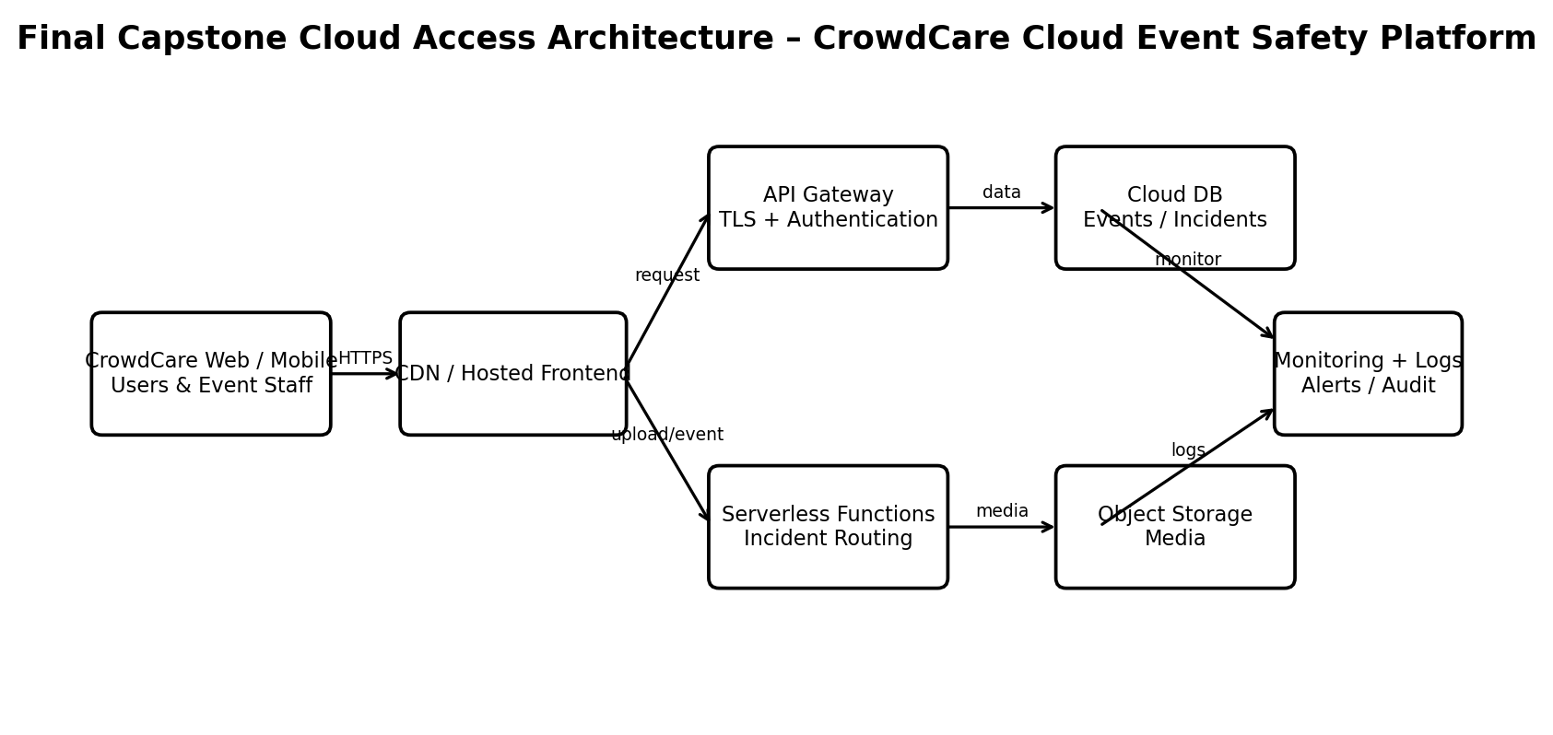
Arrow meanings: HTTPS = request/response path; request = API call; upload/event = media or sensor event; data/media = persistent cloud storage; monitor/logs = operational and audit signals.

Final Capstone Cloud Access Architecture
☐ Show Browser/Mobile Client.
☐ Show hosted frontend or app access path.
☐ Show REST API endpoint and authentication check.
☐ Show backend/serverless logic.
☐ Show database, object/blob storage, logs and monitoring.
☐ Label the arrows: request, response, upload, event, notification or monitoring signal.

Final Diagram and Explanation
Type response / paste diagram / add evidence here.

Submission Checklist
☑ Template completed in DOCX format.
☑ Diagrams pasted clearly in the document.
☑ GitHub repository contains DOCX/PDF, diagrams and README.
☑ Google Classroom submission contains GitHub link.
☑ Sensitive credentials are not visible anywhere.

Student Assurance
Declaration
I confirm that this case-study answer, cloud access design, diagrams and capstone extensions were prepared individually by me for the stated capstone title.
Student Name: Kavin.R
Register Number: 192511314
Student Signature: ____________________ Date: 25-08-2026

